AWS SECRET MANAGER

TASK 1. Store and retrieve SSH KEY

- Store a new secret.
- 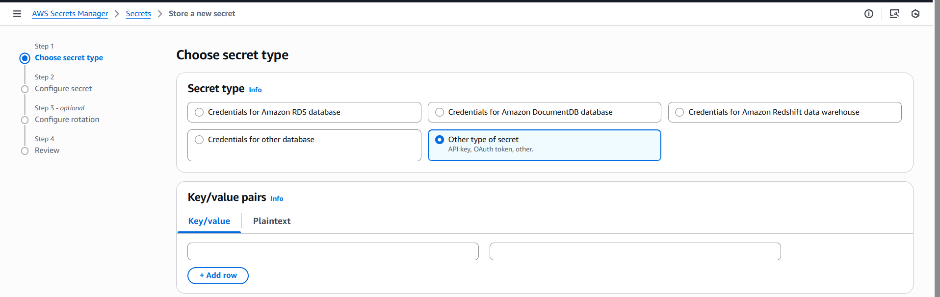
- 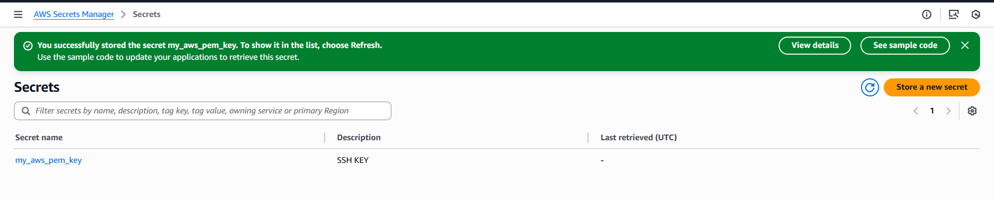
- list-secrets
- 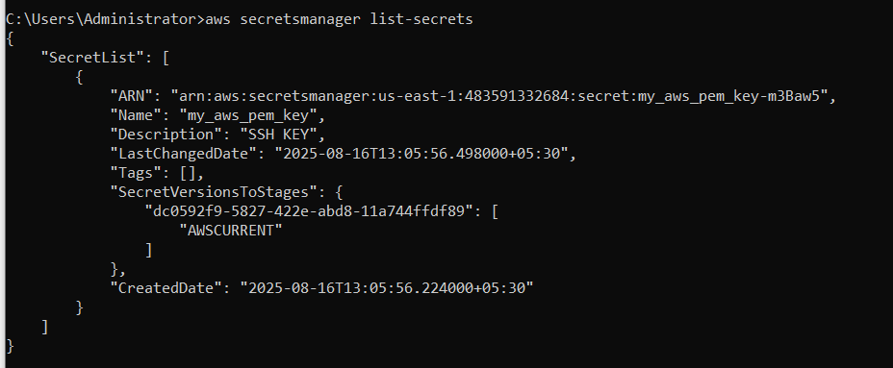
- get-secret-value
- 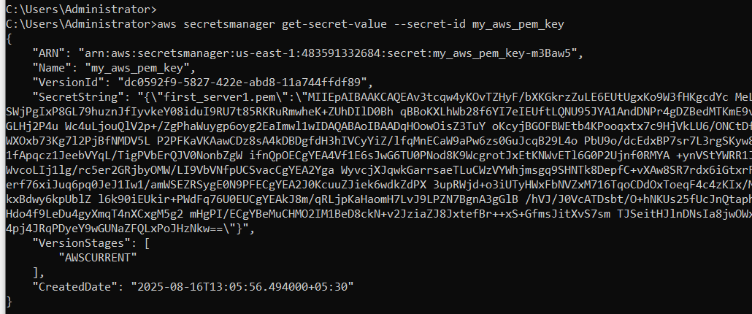

Task 2: Storing a RDS credentials and enable rotate secret keys

- Create a secret key and enable rotation for every 4 hours.
- 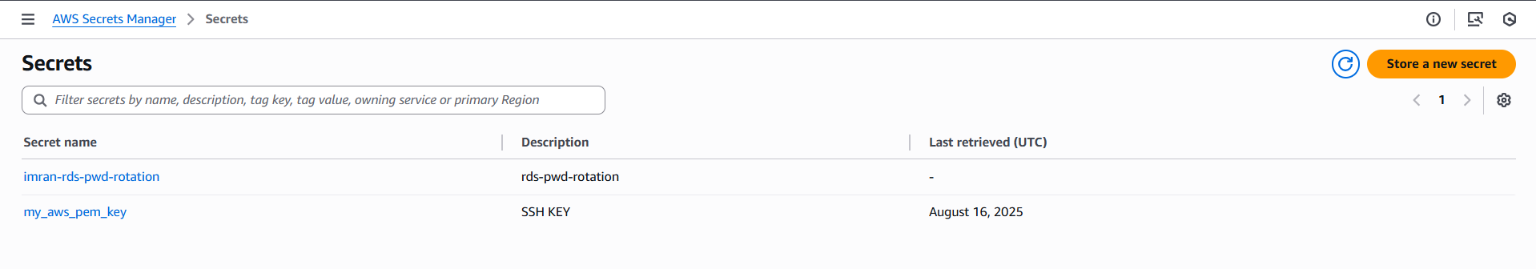
- 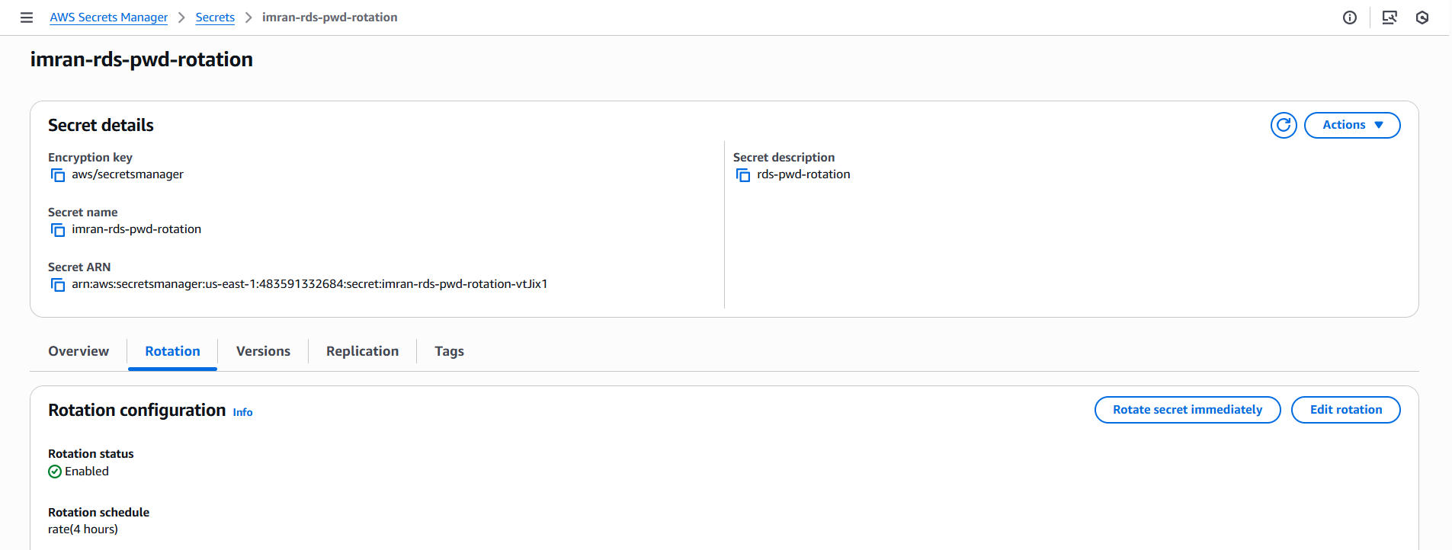
- List records
- 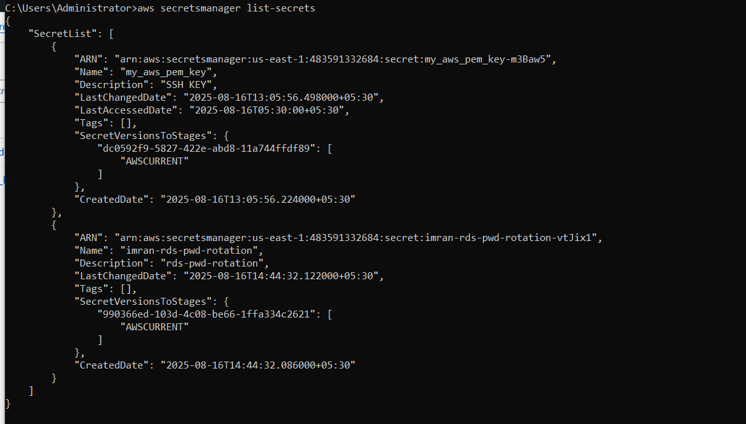
- After 4 hours its rotated and the password will be changed.
- 